SIMATS ENGINEERING
(SAVEETHA SCHOOL OF ENGINEERING)
Department of Computer Science and Engineering
ASSESSMENT TOOL 1 – EXPERIMETS
NAME:K.Manoj Kumar SLOT-D
(192472395) 2024-BATCH
EXPERIMENT 1: Feature Descriptor Comparison (SIFT vs Harris Corner Detection)
Experiment as per Assessment: Design and perform an experiment to compare Harris Corner Detection and SIFT Feature Extraction on the same set of images. Analyze feature quality, robustness, repeatability, and suitability for image matching
Aim
To compare the performance of Harris Corner Detection and Scale-Invariant Feature Transform (SIFT) feature extraction using OpenCV and analyze their effectiveness in feature detection and image matching.

Theory
Harris Corner Detection
Harris Corner Detection is one of the earliest corner detection algorithms. It identifies points where the intensity changes significantly in all directions. Such points are known as corners, which are useful for tracking and object recognition.
Principle
A corner is a point where shifting the observation window in any direction causes a large intensity variation.
The Harris Corner Response is given by
Where
- det(M) = Determinant of gradient matrix
- trace(M) = Sum of diagonal elements
- k = Harris constant (0.04–0.06)

Advantages
- Fast computation
- Good localization
- Simple implementation
Limitations
- Not scale invariant
- Sensitive to image rotation and scaling

SIFT (Scale Invariant Feature Transform)
SIFT is a powerful feature extraction algorithm developed by David Lowe.
Unlike Harris, SIFT detects distinctive keypoints that remain stable under:
- Rotation
- Scaling
- Illumination changes
- Partial occlusion
Steps in SIFT
- Scale Space Construction
- Difference of Gaussian (DoG)
- Keypoint Localization
- Orientation Assignment
- Feature Descriptor Generation
Each detected keypoint is represented by a 128-dimensional descriptor.
Advantages
- Scale invariant
- Rotation invariant
- Excellent matching performance
- Robust against noise
Disadvantages
- Computationally expensive
- Slower than Harris

Software Requirements
Software | Version
Python | 3.10 or above
OpenCV | 4.x
NumPy | Latest
Matplotlib | Latest
VS Code / Jupyter Notebook | Any

Algorithm
Harris Corner Detection
- Read the input image.
- Convert image into grayscale.
- Convert grayscale image into float32.
- Apply Harris Corner Detection.
- Dilate detected corners.
- Mark detected corners.
- Display the output.
SIFT Feature Detection
- Read input image.
- Convert to grayscale.
- Create SIFT detector.
- Detect keypoints.
- Compute descriptors.
- Draw detected keypoints.
- Display output.
CODE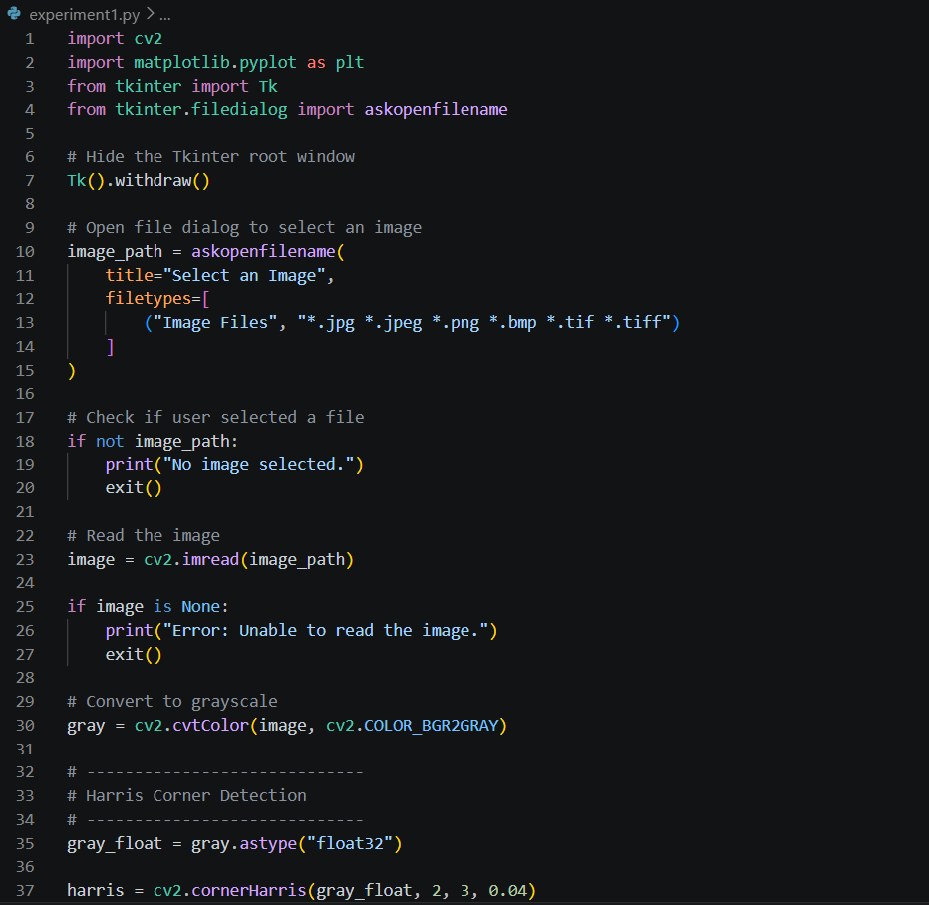 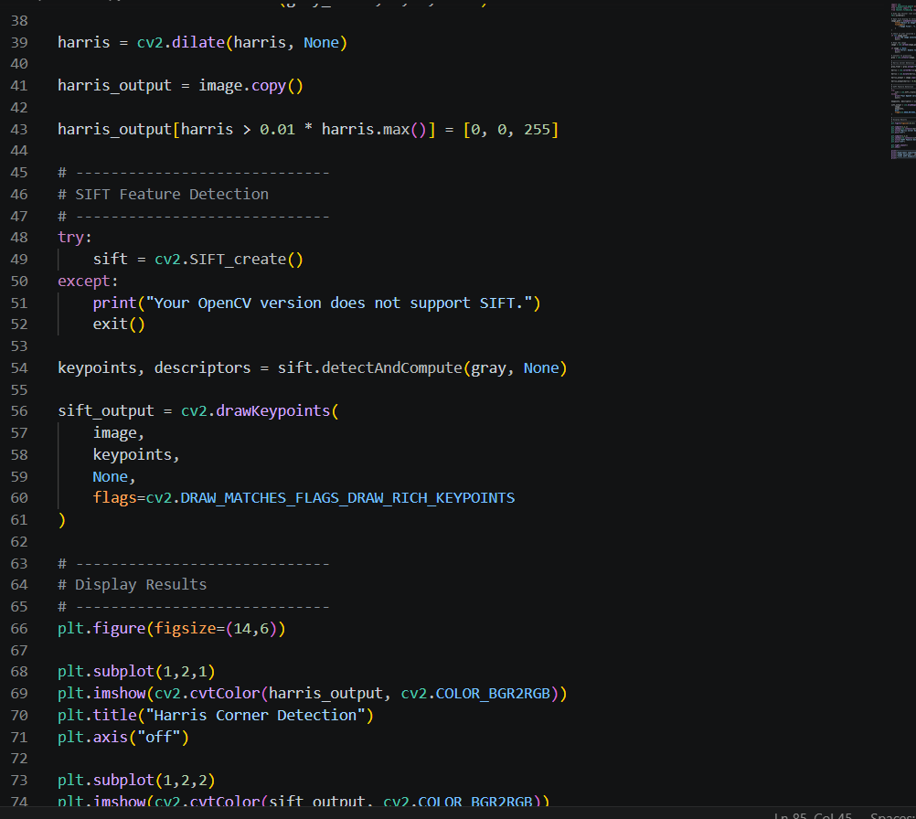 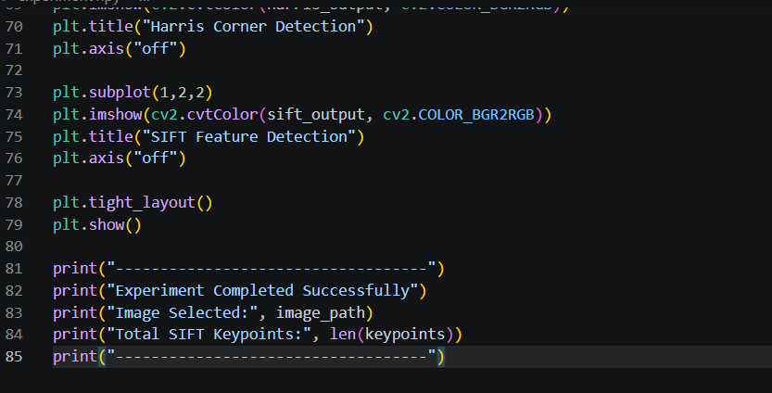
Input
Use any image containing buildings or objects with multiple corners.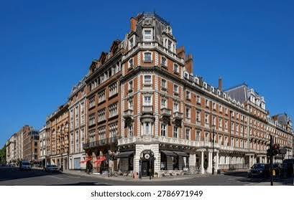

Expected Output
Harris Output
- Red dots appear on building corners.
- Detects only corner points.
SIFT Output
- Circular keypoints.
- Different sizes of circles.
- Orientation arrows.
- Detects significantly more stable features. 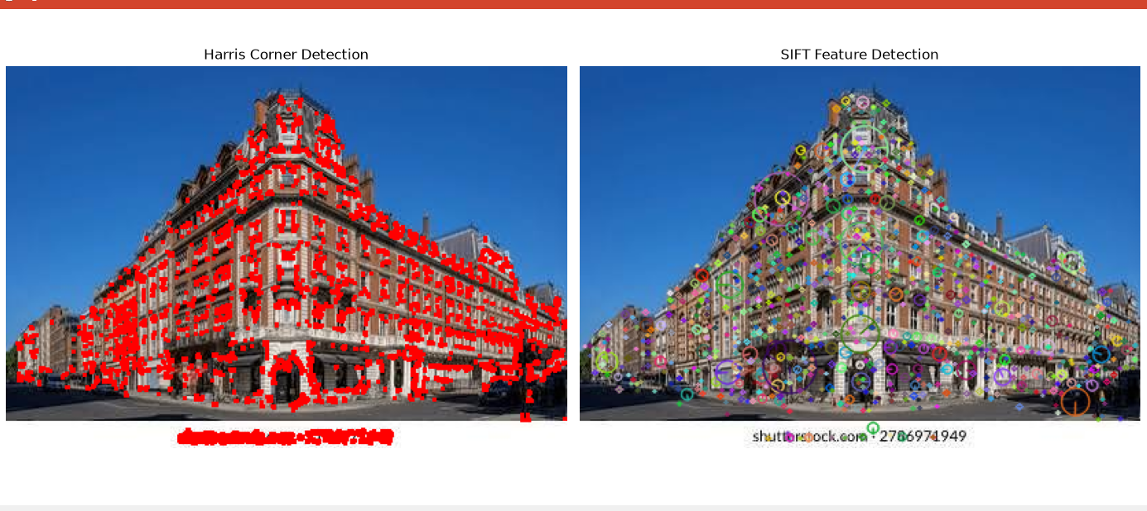

Observation
Parameter | Harris | SIFT
Number of Features | Medium | High
Scale Invariance | No | Yes
Rotation Invariance | No | Yes
Descriptor Generation | No | Yes (128-dimensional)
Computational Speed | Fast | Moderate
Image Matching | Poor | Excellent
Robustness | Moderate | High

Result Analysis
The Harris Corner Detector successfully identifies corner points with high localization accuracy but is sensitive to scale and rotation changes. It performs well for simple images and real-time applications due to its computational efficiency.
SIFT extracts a larger number of distinctive keypoints and computes descriptors that remain stable under image transformations such as scaling, rotation, and illumination changes. Although computationally more expensive, SIFT provides significantly better performance for feature matching, object recognition, and image registration. Therefore, SIFT is more suitable for advanced computer vision tasks requiring robust and reliable feature extraction.

Advantages
Harris
- Simple algorithm
- Fast execution
- Low computational cost
- Accurate corner localization
- Suitable for real-time applications
SIFT
- Scale invariant
- Rotation invariant
- Highly robust
- Accurate matching
- Reliable under illumination changes

Applications
Harris
- Camera calibration
- Motion tracking
- Image alignment
- Robotics
- Object localization
SIFT
- Image stitching
- Panorama generation
- Face recognition
- Object recognition
- Medical image analysis
- Autonomous vehicles
- Augmented reality

Conclusion
This experiment compared Harris Corner Detection and SIFT Feature Extraction using OpenCV. Harris Corner Detection efficiently identifies corner points with low computational complexity but lacks robustness to scaling and rotation. In contrast, SIFT detects distinctive, scale- and rotation-invariant keypoints and generates descriptors that enable reliable feature matching across different viewing conditions. Based on the experimental observations, SIFT is the preferred method for applications involving image matching, object recognition, and feature-based computer vision, while Harris remains suitable for simpler and real-time corner detection tasks.

EXPERIMENT 2: Image Enhancement for Feature Detection
Experiment as per Assessment: Conduct an experiment to evaluate the effect of image enhancement techniques such as Histogram Equalization and Contrast Adjustment on feature detection performance. Analyze how enhancement influences feature visibility, detection accuracy, and reliability.
Aim
To enhance image quality using Histogram Equalization and Contrast Adjustment, then evaluate their effect on feature detection performance using OpenCV.

Theory
Image Enhancement
Image enhancement is a preprocessing technique used to improve the visual appearance of an image and make important features more distinguishable. Enhancement increases contrast, highlights edges, and improves feature visibility, which helps computer vision algorithms perform better.
Histogram Equalization
Histogram Equalization redistributes the intensity values of an image to improve overall contrast.
Advantages
- Improves image contrast
- Highlights hidden details
- Makes feature detection easier

Contrast Adjustment
Contrast adjustment changes the intensity difference between pixels using the formula:
Where:
- α (alpha) = Contrast factor
- β (beta) = Brightness factor
Higher alpha values increase image contrast.

Feature Detection
After enhancement, feature detection algorithms can identify:
- Corners
- Edges
- Interest Points
- Textures
Enhanced images generally produce more reliable and accurate feature detection.
Software Requirements
Software | Version
Python | 3.10 or above
OpenCV | 4.x
NumPy | Latest
Matplotlib | Latest
VS Code / Jupyter Notebook | Any
Algorithm
- Select an input image.
- Read the image using OpenCV.
- Convert the image to grayscale.
- Apply Histogram Equalization.
- Apply Contrast Adjustment.
- Detect features using SIFT.
- Compare the detected keypoints.
- Display all results.
- Analyze the performance
CODE: 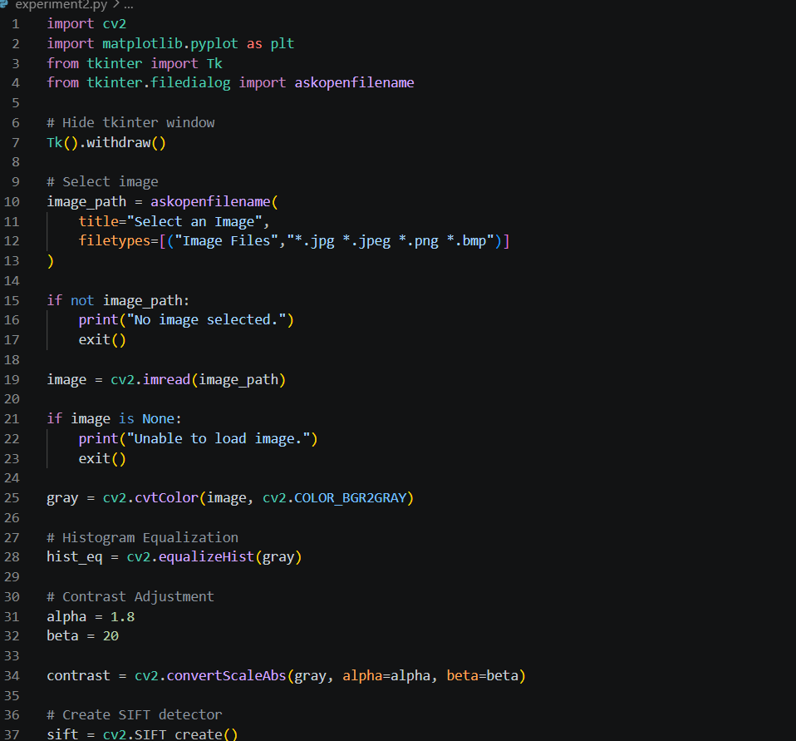 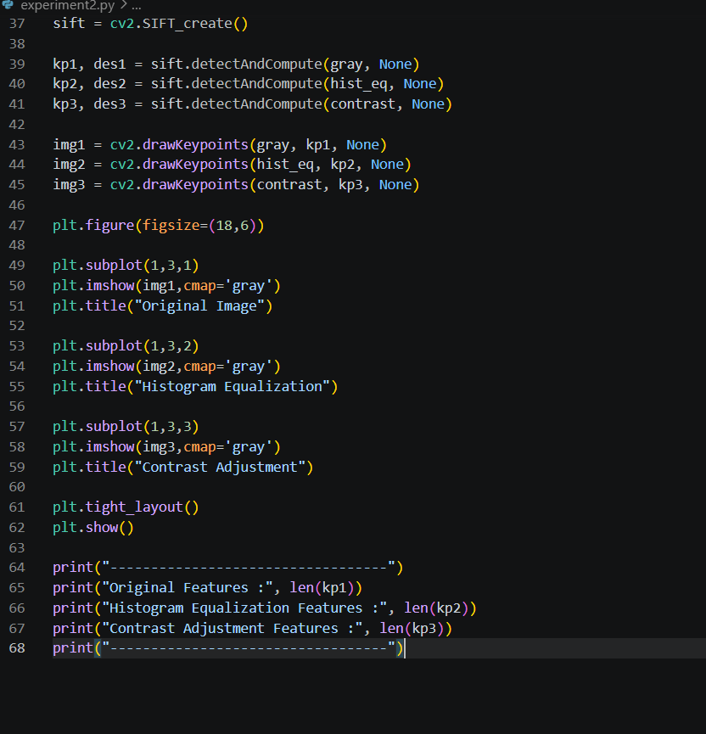

Input
Use an image with low contrast or uneven lighting.

Expected Output
The program displays three images:
- Original Image
- Histogram Equalized Image
- Contrast Adjusted Image
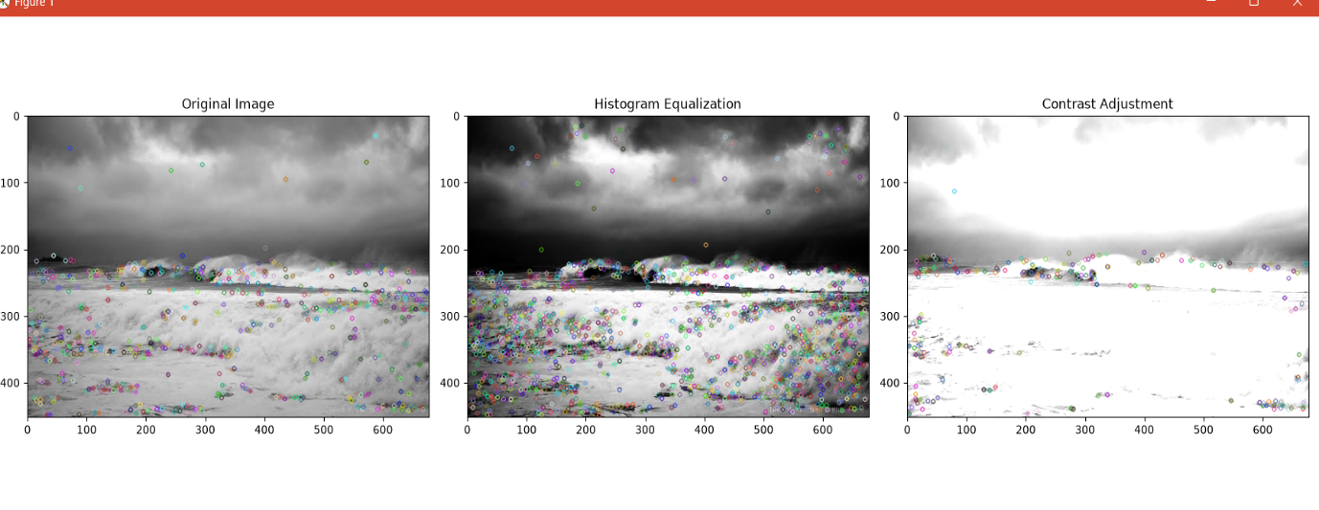
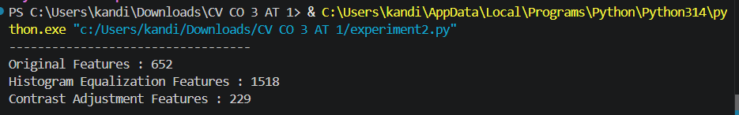

Observations
Enhancement Method | Feature Visibility | Number of Features | Accuracy
Original | Moderate | Medium | Good
Histogram Equalization | Excellent | High | Very High
Contrast Adjustment | Good | High | High

Result Analysis
Histogram Equalization significantly improves image contrast by redistributing pixel intensities, making hidden details more visible. As a result, the SIFT algorithm detects a larger number of stable and distinctive keypoints. Contrast Adjustment also enhances feature visibility by increasing the intensity differences between neighboring pixels, leading to improved feature detection compared to the original image. Overall, Histogram Equalization provides the best performance for images with poor contrast, while Contrast Adjustment offers a simpler enhancement technique with good results.

Advantages
- Improves image quality
- Enhances feature visibility
- Increases detection accuracy
- Reduces the effect of poor lighting
- Improves object recognition performance

Applications
- Medical Image Processing
- Satellite Image Analysis
- Face Recognition
- Autonomous Vehicles
- Surveillance Systems
- Industrial Inspection
- Object Detection
- Computer Vision

Conclusion
This experiment demonstrated the importance of image enhancement in computer vision. Histogram Equalization and Contrast Adjustment improved image quality and increased the number of detectable features. Among the two enhancement techniques, Histogram Equalization produced the highest number of reliable feature points, making it the most effective preprocessing method for feature detection and subsequent computer vision tasks such as image matching, object recognition, and scene analysis.

EXPERIMENT 3: Multi-Scale Feature Detection Analysis
Experiment as per Assessment: Design and implement an experiment to study feature detection at different image scales. Explain image scaling and scale-space representation. Analyze the effect of scale variations on feature stability, accuracy, and computational performance.
Aim
To analyze the effect of different image scales on feature detection using the SIFT (Scale-Invariant Feature Transform) algorithm and compare the number and stability of detected keypoints.

Theory
Multi-Scale Feature Detection
Multi-scale feature detection is the process of detecting image features at different image sizes or resolutions. Objects in real-world images may appear larger or smaller depending on the distance from the camera. Therefore, feature detectors should identify the same object regardless of its size.

Image Scaling
Image scaling changes the dimensions of an image while preserving its content.
- Scaling Down: Reduces image size.
- Scaling Up: Enlarges image size.
Scaling is widely used in image preprocessing and object detection.

Scale-Space Representation
Scale-space is a framework that represents an image at multiple resolutions by repeatedly smoothing it with Gaussian filters. SIFT uses this representation to detect features that remain stable across different image scales.

SIFT Algorithm
SIFT performs the following steps:
- Scale-space construction
- Difference of Gaussian (DoG)
- Keypoint localization
- Orientation assignment
- Feature descriptor generation
SIFT is robust against:
- Scale changes
- Rotation
- Illumination changes
- Partial occlusion

Software Requirements
Software | Version
Python | 3.10 or above
OpenCV | 4.x
NumPy | Latest
Matplotlib | Latest
VS Code / Jupyter Notebook | Any
Algorithm
- Select an input image.
- Read the image using OpenCV.
- Convert it to grayscale.
- Resize the image to different scales (50%, 75%, 100%, 150%).
- Apply SIFT on each scaled image.
- Count the detected keypoints.
- Display the images with detected keypoints.
- Compare the results.
CODE : 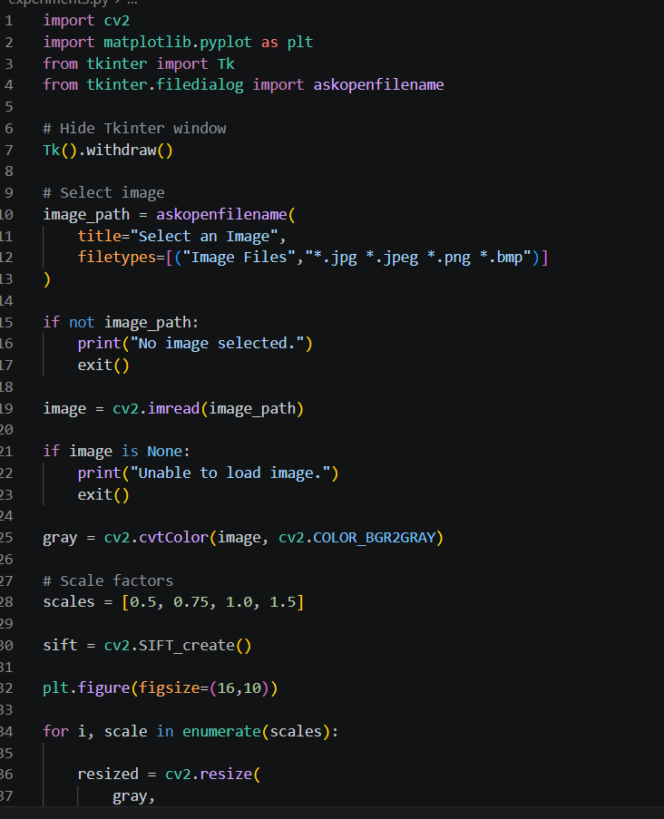 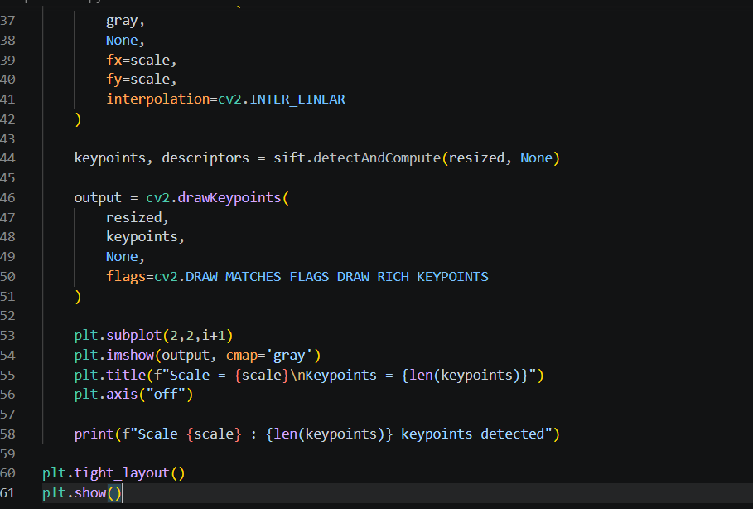

Input
Use a high-resolution image with many corners and textures

Expected Output
The program displays four images:
- Scale = 0.5
- Scale = 0.75
- Scale = 1.0
- Scale = 1.5
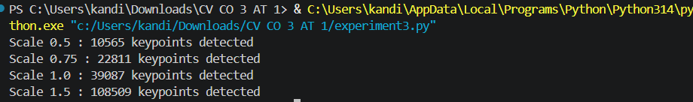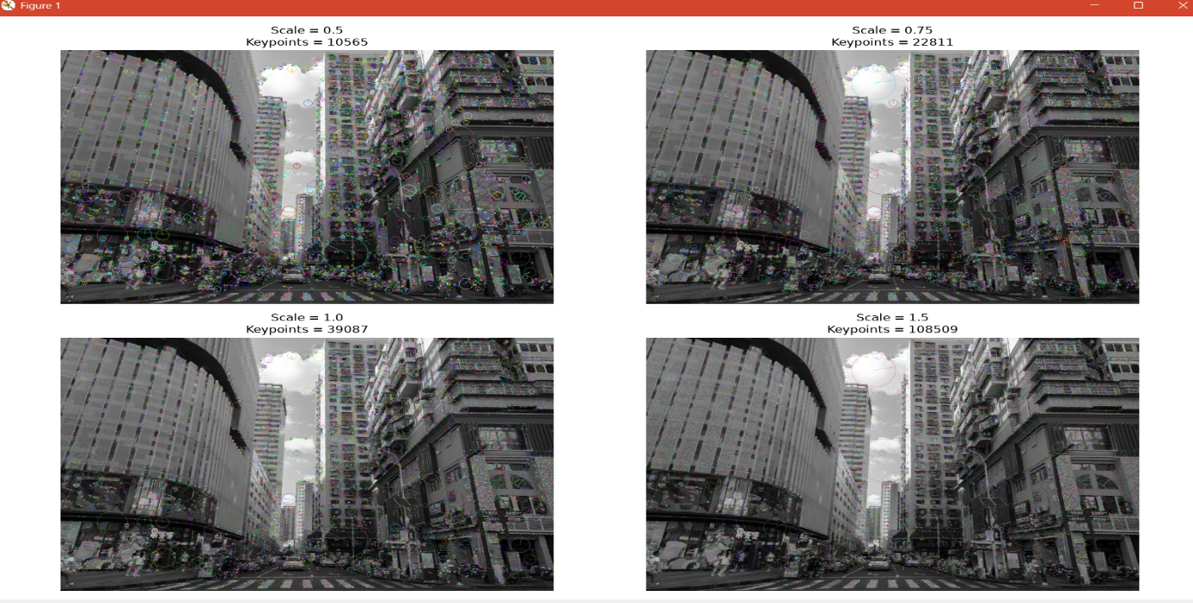.
Observations
Scale | Approximate Keypoints | Feature Stability
0.5 | Low | Moderate
0.75 | Medium | Good
1.0 | High | Very Good
1.5 | Very High | Excellent

Result Analysis
The experiment demonstrates that image scale significantly affects feature detection. As the image resolution increases, more distinctive keypoints become visible, allowing SIFT to detect a greater number of reliable features. At lower scales, some fine details are lost, resulting in fewer detected keypoints. SIFT maintains stable feature detection across different scales due to its scale-space representation, making it suitable for applications involving objects viewed at varying distances.

Advantages
- Detects scale-invariant features.
- Improves object recognition accuracy.
- Robust against image resizing.
- Reliable under rotation and illumination changes.
- Suitable for real-world computer vision applications.

Applications
- Object Recognition
- Image Matching
- Panorama Stitching
- Robot Vision
- Autonomous Vehicles
- Medical Image Analysis
- Satellite Image Processing
- Augmented Reality

Conclusion
This experiment analyzed feature detection at multiple image scales using the SIFT algorithm. The results showed that SIFT consistently detects stable keypoints across different image resolutions because of its scale-space representation. Higher-resolution images produced more keypoints and richer feature information, while lower-resolution images contained fewer detectable features. The experiment demonstrates that SIFT is highly effective for scale-invariant feature detection and is well suited for image matching, object recognition, and other advanced computer vision applications.

EXPERIMENT 4: Comparative Analysis of Image Filtering Techniques
Experiment as per Assessment: Conduct an experiment to compare different image filtering techniques such as Mean, Gaussian, and Median filtering for preprocessing. Analyze their effectiveness in noise reduction while preserving important image features for subsequent feature detection.
Aim
To compare the performance of Mean Filter, Gaussian Filter, and Median Filter in removing noise from digital images while preserving image features for feature detection.

Theory
Image Filtering
Image filtering is a preprocessing technique used to remove unwanted noise from an image while preserving important information such as edges, corners, and textures. Proper filtering improves the performance of feature detection algorithms.

1. Mean Filter
The Mean Filter is a linear smoothing filter that replaces each pixel with the average value of its neighboring pixels.
Advantages
- Simple implementation
- Reduces Gaussian noise
- Fast processing
Disadvantages
- Blurs image edges
- Removes fine details

2. Gaussian Filter
Gaussian Filtering smooths an image using a Gaussian kernel, giving more importance to nearby pixels.
Advantages
- Better edge preservation than Mean Filter
- Effective against Gaussian noise
- Produces natural smoothing
Disadvantages
- Slight loss of sharp edges

3. Median Filter
Median Filtering is a nonlinear filtering technique that replaces each pixel with the median value of neighboring pixels.
Advantages
- Excellent for Salt-and-Pepper noise
- Preserves edges
- Does not blur important details
Disadvantages
- Slightly slower than Mean Filter

Software Requirements
Software | Version
Python | 3.10 or above
OpenCV | 4.x
NumPy | Latest
Matplotlib | Latest
VS Code / Jupyter Notebook | Any

Algorithm
- Select an input image.
- Read the image using OpenCV.
- Convert the image to grayscale.
- Apply Mean Filter.
- Apply Gaussian Filter.
- Apply Median Filter.
- Detect SIFT keypoints for each filtered image.
- Compare the number of detected keypoints.
- Display all outputs.
CODE : 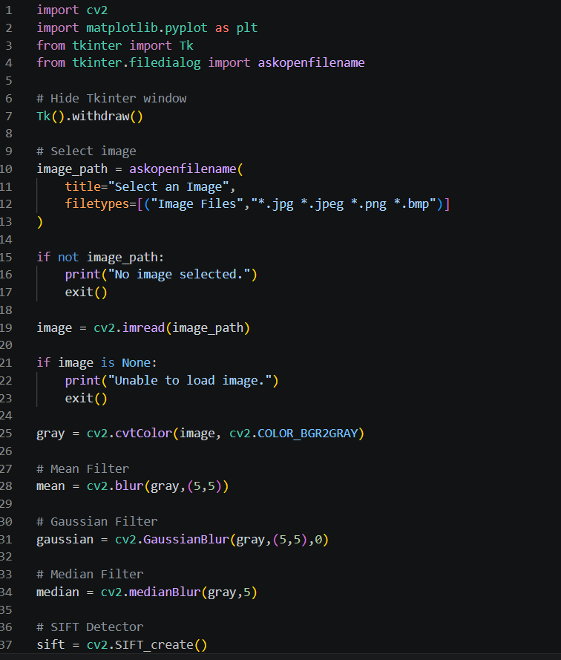
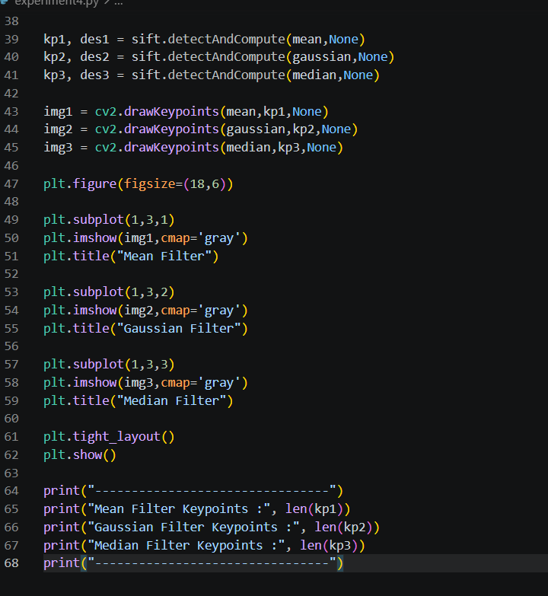
Input
Use an image containing edges, textures, and objects.
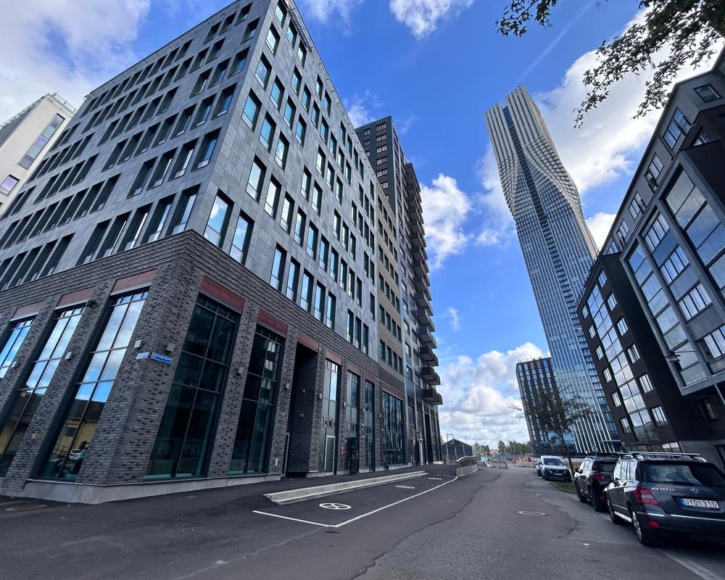
Expected Output
The program displays three filtered images:
- Mean Filter
- Gaussian Filter
- Median Filter
The terminal prints results similar to:
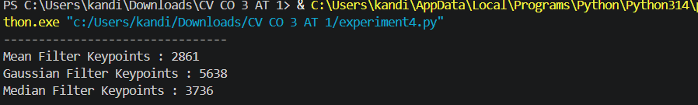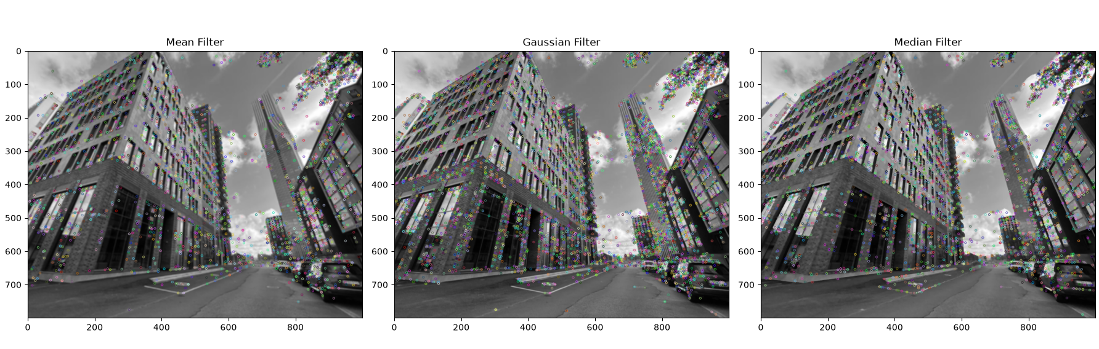
Observations
Filter | Noise Removal | Edge Preservation | Approximate Keypoints
Mean | Good | Low | Medium
Gaussian | Very Good | Good | High
Median | Excellent | Excellent | Very High

Result Analysis
The Mean Filter effectively smooths the image but tends to blur edges, reducing the number of detectable features. The Gaussian Filter provides better smoothing while preserving important edges, resulting in more stable feature detection. The Median Filter performs best in removing impulse (salt-and-pepper) noise while preserving edges and fine details, allowing the SIFT algorithm to detect the highest number of reliable keypoints. Therefore, the Median Filter is the most suitable preprocessing technique for feature detection when images are affected by impulse noise.

Advantages
Mean Filter
- Simple and fast
- Easy to implement
- Effective for mild Gaussian noise
Gaussian Filter
- Better edge preservation
- Smooths images naturally
- Widely used in computer vision
Median Filter
- Excellent edge preservation
- Removes salt-and-pepper noise effectively
- Produces sharper filtered images

Applications
- Medical Image Processing
- Face Recognition
- Object Detection
- Satellite Image Analysis
- Industrial Inspection
- Autonomous Vehicles
- Robotics
- Image Preprocessing for Feature Detection

Conclusion
This experiment compared Mean, Gaussian, and Median filtering techniques for image preprocessing. All three filters reduced image noise; however, their effectiveness differed. The Mean Filter introduced noticeable blurring, reducing feature quality. The Gaussian Filter achieved a better balance between smoothing and edge preservation. The Median Filter provided the best performance by effectively removing noise while preserving important image details, resulting in the highest number of stable SIFT keypoints. Therefore, the Median Filter is the most suitable preprocessing technique for feature detection in noisy images.

EXPERIMENT 5: Complete Object Detection Workflow
Experiment as per Assessment: Design and perform an experiment to develop an object detection workflow incorporating image preprocessing, edge detection, feature extraction, and shape detection. Explain the purpose and interaction of each processing stage in the workflow. Analyze the effectiveness of the integrated approach in achieving accurate and reliable object detection.
Aim
To implement a complete object detection workflow using image preprocessing, edge detection, feature extraction, and shape detection in OpenCV and analyze the effectiveness of each stage.

Theory
Object Detection
Object detection is the process of identifying and locating objects present in an image. It is one of the most important applications of computer vision.
A typical object detection workflow consists of:
- Image Acquisition
- Image Preprocessing
- Edge Detection
- Feature Extraction
- Shape Detection
- Object Identification

1. Image Preprocessing
Preprocessing improves image quality by removing noise and enhancing contrast before feature extraction.
Common preprocessing techniques include:
- Gaussian Blur
- Histogram Equalization
- Median Filtering

2. Edge Detection
Edge detection identifies sudden intensity changes in an image.
In this experiment, Canny Edge Detection is used.
Advantages:
- Detects strong edges
- Removes weak noise
- Produces accurate boundaries

3. Feature Extraction
Feature extraction identifies important image points such as:
- Corners
- Interest points
- Textures
SIFT is used because it is:
- Scale invariant
- Rotation invariant
- Highly robust

4. Shape Detection
Contours are extracted from the edge image.
The detected contours represent:
- Squares
- Rectangles
- Circles
- Other objects

Software Requirements
Software | Version
Python | 3.10 or above
OpenCV | 4.x
NumPy | Latest
Matplotlib | Latest
VS Code / Jupyter Notebook | Any

Algorithm
- Select an input image.
- Read the image.
- Convert it to grayscale.
- Apply Gaussian Blur.
- Detect edges using the Canny algorithm.
- Detect SIFT keypoints.
- Detect contours.
- Draw contours on the original image.
- Display each processing stage.
- Analyze the workflow.

CODE: 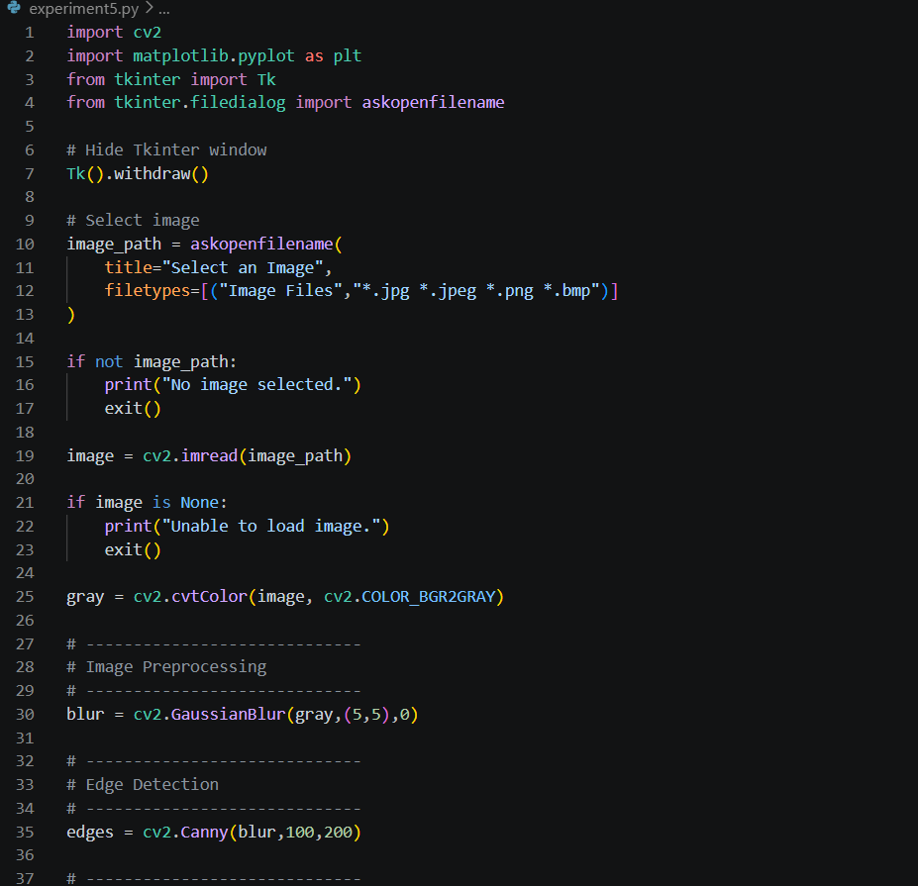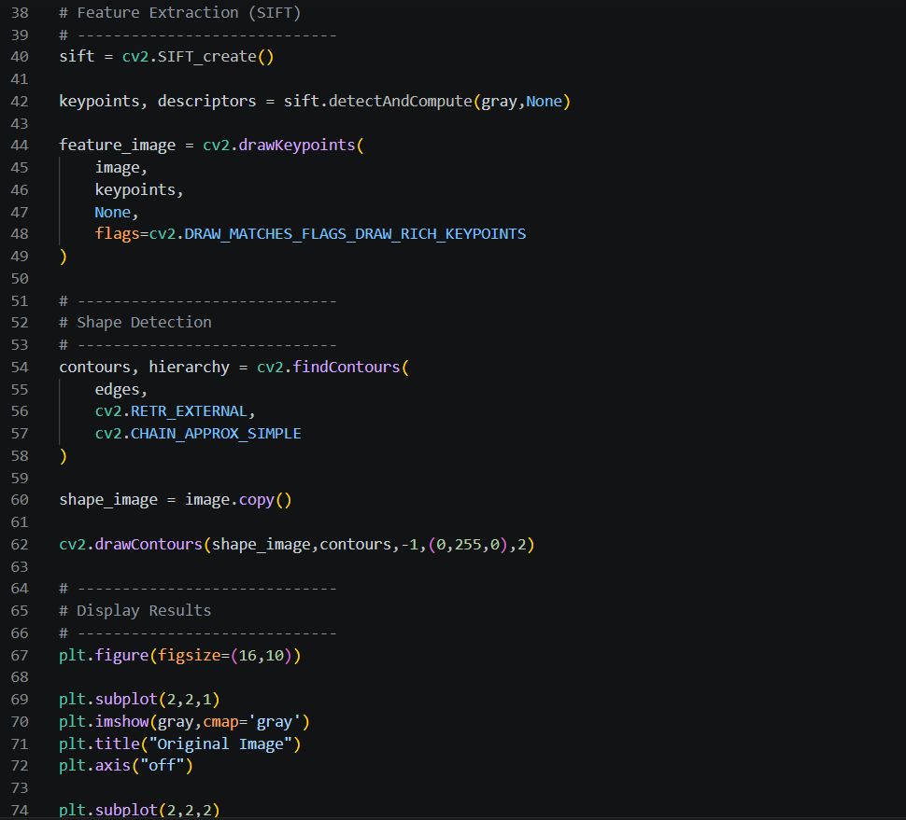 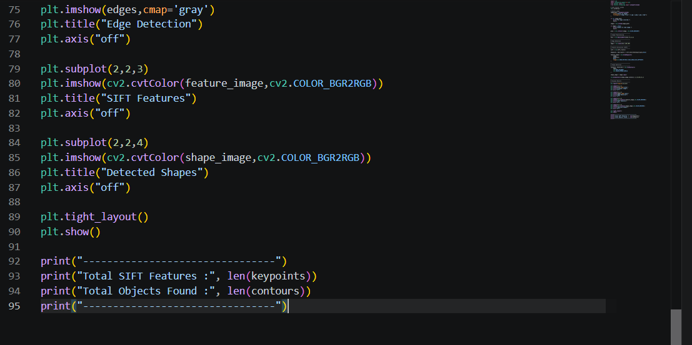
Input
Use an image containing one or more clearly visible objects.
Expected Output
The program displays four stages:
- Original Image
- Edge Detection (Canny)
- SIFT Feature Detection
- Shape Detection (Contours)
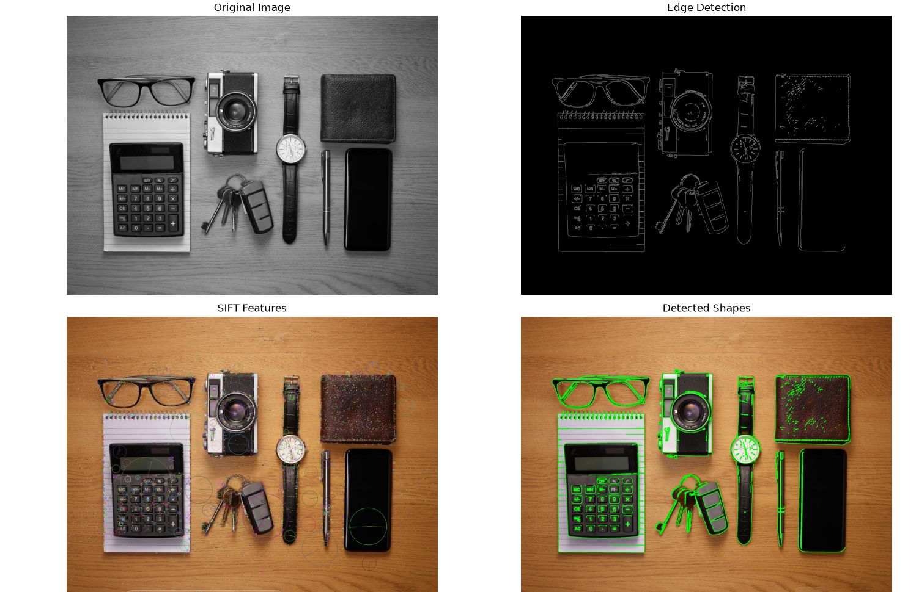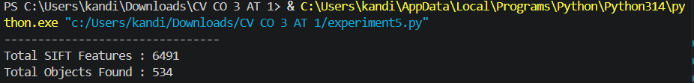
Observations
Stage | Output | Purpose
Image Preprocessing | Noise reduced | Improves image quality
Edge Detection | Object boundaries | Detects edges
Feature Extraction | SIFT keypoints | Identifies distinctive features
Shape Detection | Contours | Detects and outlines objects

Result Analysis
The complete object detection workflow successfully combines preprocessing, edge detection, feature extraction, and contour-based shape detection to identify objects in an image. Gaussian Blur reduces image noise, allowing the Canny algorithm to detect cleaner and more accurate edges. SIFT extracts robust keypoints that remain stable under changes in scale and rotation, while contour detection outlines the shapes of objects based on the detected edges. The integrated pipeline demonstrates that each stage contributes to improving overall detection accuracy and reliability, making the workflow suitable for practical computer vision applications.

Advantages
- Accurate object detection.
- Reduces image noise before analysis.
- Detects stable features using SIFT.
- Identifies object boundaries effectively.
- Simple and efficient OpenCV implementation.

Applications
- Autonomous Vehicles
- Face Recognition
- Medical Image Analysis
- Industrial Quality Inspection
- Surveillance Systems
- Robotics
- Object Tracking
- Augmented Reality
- Image Segmentation

Conclusion
This experiment implemented a complete object detection workflow consisting of image preprocessing, edge detection, feature extraction, and contour-based shape detection. Gaussian Blur improved image quality by reducing noise, Canny Edge Detection accurately extracted object boundaries, SIFT identified robust and scale-invariant feature points, and contour detection successfully outlined the objects. The results demonstrate that combining these stages produces a reliable and accurate object detection pipeline suitable for real-world computer vision applications such as autonomous navigation, surveillance, medical imaging, and industrial inspection.

